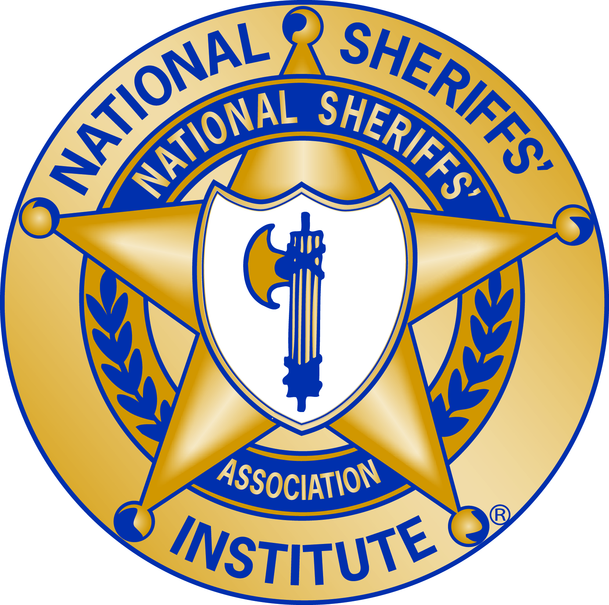

National Institute of Corrections National Sheriffs’ Association

Monday
8:00 am | Module 1: Welcome and Introductions
9:30 am | Module 2: The Sheriff as Leader
12:15 pm | Lunch
1:15 pm | Module 3: Defining Your Leadership Direction
5:00 pm | Adjourn
5:30 pm | Evening Session: The Office of Sheriff and the NSA

Tuesday
8:00 am | Module 4: Self-Awareness
12:00 pm | Lunch
12:45 pm | NIC Information Center and Library Visit
1:15 pm | Module 5: Developing Your Executive Team
4:30 pm | Adjourn

Wednesday
8:00 am | Module 6: Power, Influence and Conflict
12:00 pm | Lunch
12:45 pm | Module 7: Ethics
3:15 pm | NIC Overview
4:30 pm | Adjourn

Thursday
8:00 am | Module 8: External Environment and Public Partnerships
12:00 pm | Lunch
12:45 pm | Module 8: External Environment and Public Partnerships
1:30 pm | Module 9: Leading Change
4:30 pm | Adjourn

Friday
8:00 am | Graduation Pictures
8:30 am | Module 9: Leading Change
12:00 pm | Lunch
12:45 pm | Module 10: Leadership Development Plan
4:30 pm | Graduation
5:00 pm | Adjourn

