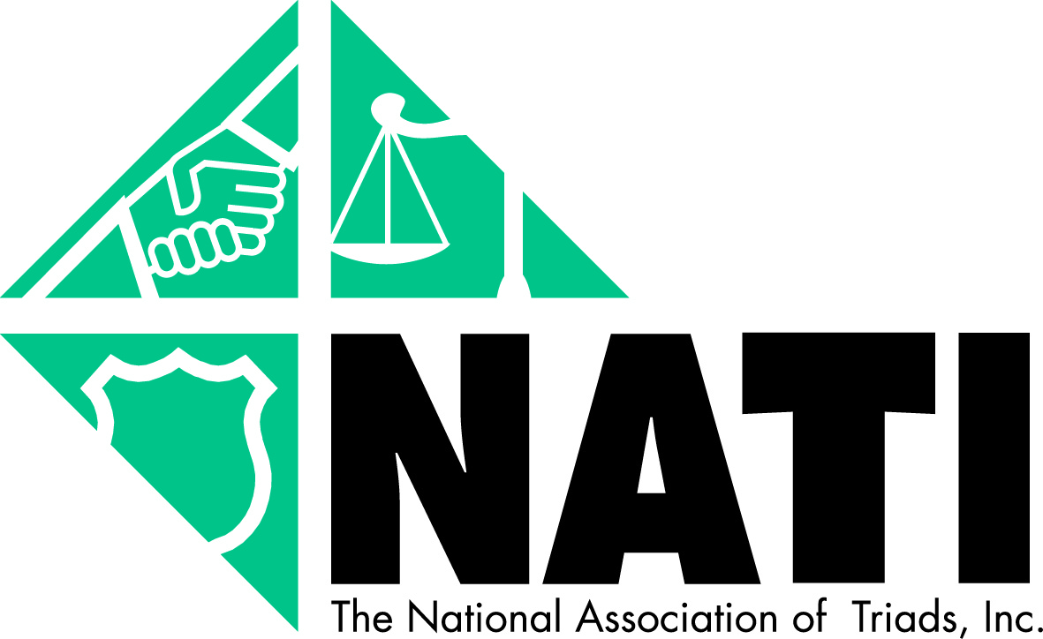

Senior Investor Traps
"Free lunch" investment seminars. There's no such thing as a "free" lunch. Promoters often use the promise of a free meal to lure potential clients to hear pitches of unsuitable or questionable investments.
Variable Annuity Sales Practices. Variable annuities are tax-deferred investments that typically place mutual funds inside of an insurance wrapper for tax deferred potential investment growth. While these products are legitimate investments, regulators are concerned about their popularity in the sales community. Commissions on sales of variable annuities are very high, which provides incentive for sellers to engage in inappropriate sales. Variable annuities are only suitable for a small percentage of the investing public and generally are not appropriate for most seniors.
Personal Information Scams. The first step in separating a victim from his or her money is convincing the victim to divulge personal financial information. A pretext that is of current concern to insurance and securities regulators is the offer to help senior citizens qualify for prescription benefits by preparing forms. In the guise of filling out forms, the scamster may ask unnecessary questions about personal financial assets. To the con artist, this information provides a comprehensive laundry list of what is available for the taking.
Oil and Gas Investment Fraud. High oil prices mean oil and gas scams will continue to attract victims. Oil and gas deals are complicated investments that generally require a significant investment, often requiring a minimum deposit of thousands of dollars. Increasingly, these deals are being promoted via the Internet with claims of attractive tax advantages. Overall, these deals are highly risky, but the lure of high profits often proves irresistible to investors.
Prime Bank Schemes. These schemes often promise high-yield, tax-free returns that are said to result from "off-shore trades of bank debentures." Investors are told that only very wealthy people can get the benefit of these programs but the promoter is able to make it available to the victim. There are no such programs. These prime bank schemes are the securities equivalent of a purse snatch. Once the seller has your money, it's gone "off shore" forever.
Recovery Rooms. Scam artists buy and sell the names and financial information of victims who have lost money to "recovery room" operators who promise, in return for a fee that the victim must pay in advance, to recover the money lost in a worthless investment. These "sucker lists" are bought by crooks who know that people who have been deceived once are vulnerable to additional scams; especially scams that give hope of recovering lost money.
– Source: North American Securities Administrators Association, Inc.

