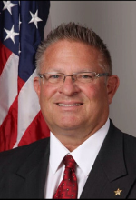
Sheriff Ken Briley
Grundy County, Illinois

My name is Ken Briley I am the Sheriff in Grundy County, Illinois. I was elected to office in December 2018.

Prior to becoming Sheriff, I served the Minooka Police Department in Minooka, Illinois from 2005 until 2018. In my last 4 years at Minooka, I served as the School Resource Officer (SRO) for Minooka Community High School, a junior and senior campus serving approx. 1700 students.

I began my law enforcement career in 1981 as a Correctional Officer at the historic Joliet Correctional Center in Joliet, Illinois, famous for The Blues Brothers movie. I held many different ranks and job duties over the next 23+ years. I finished my career with IDOC as the Warden of Stateville Correctional Center in Cresthill, Illinois, where I served from 2000-2005.

One significant accomplishment while serving in the SRO position was that we were able to certify 7 schools, along with hundreds of teachers and students in Minooka K-12 in A.L.I.C.E. techniques.

I am very passionate about school security and I am very proud to serve on this committee.

