BIO

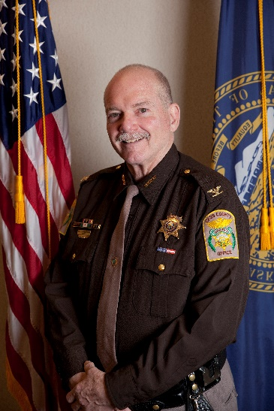
William (Bill) Brueggemann

Sheriff Brueggemann has been in Law Enforcement for 34 years, 29 of those as Sheriff in Cass County Nebraska. Having worked up through the ranks as a Corrections Officer, Deputy, Investigator and now Sheriff, he continues to look forward to going to work every day to do what cops do….help people. Bill and his wife Cathleen have made their home in Plattsmouth (the County seat) and have 4 grown children A few of his past affiliation include serving as Vice-Chair for the DOJ’s Rural Law Enforcement Technology Committee (RULETC), Vice-Chair for the DOJ’s Small Rural Tribal Border Research Center (SRTBRC), Chairman on the “Small/Rural Sheriff’s Committee for the National Sheriff’s Association, member of the Nebraska Crime Commission which oversees all law enforcement in the State and Past President of the Nebraska Sheriff’s Association.

Sheriff Brueggemann is currently serving as Chair on the School Safety Committee for the National Sheriff’s Association, the Nebraska representative on the Board for the Western States Sheriff’s Association, he serves as Chairman for Rural and Tribal law enforcement working group on the Presidents Commission for Law Enforcement and Criminal Justice, Executive Board member for the Nebraska Sheriff’s Association and has served 13 years with the Nebraska National Guard.

Having dedicated much of his career to the youth, Bill is also a DARE (Drug Abuse Resistance Education) instructor, A GREAT (Gang Resistance Education and Training) instructor, a SRO (School Resource Officer), an Explorer Post leader, a High School Business Mentor, a Team-Mate mentor for children, and a Church Youth Leader.

