

GRPAHIC USER INTERFACE

Classroom Signaling Station signaling under threat
Teacher Activated

, need help—
Teacher Activated


**Threat Receiver in Alarm**

**Motion Detector in Alarm—Subject is within 20 ft.**

**Camera Icon—Left Click Accesses Live Video**

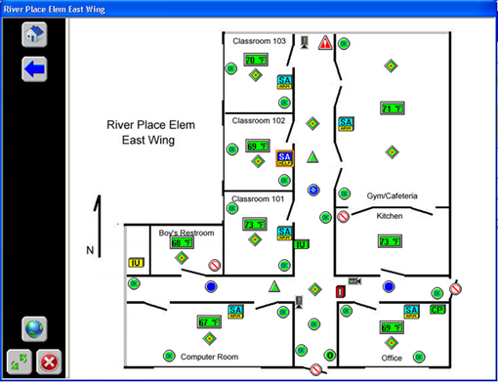

Camera Icon—a left click brings
up live video of the subject


Motion in Alarm
Subject is within 20 ft of the detector
F and D indicate a Hot Zone
a

F and D are the firing command sequence 

**Tactical Workstation w/ video pulled**

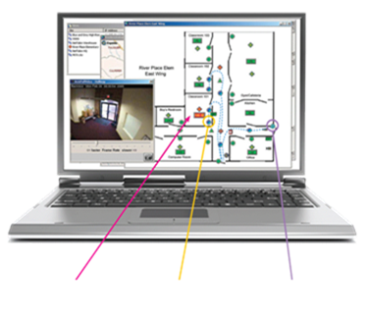

**Sensor Multistate Conditions Provide**

**Continuous Real-time Actionable**

**Intelligence**

**Hot Zones Centered on Motion Detectors**

**Motion are in disarmed condition—Normal School Day**

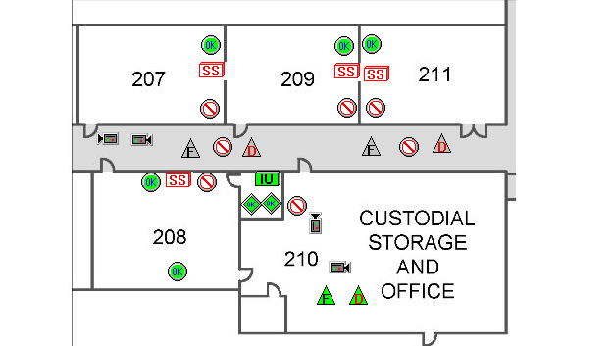

**Figure 7 - Counter Measures Monitoring Screen**

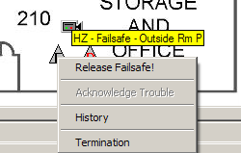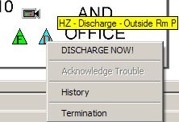

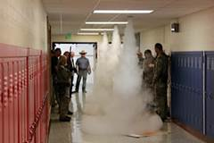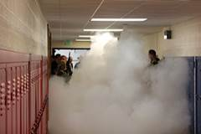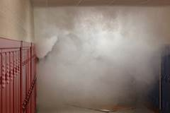

**Figure 8 - Counter Measures Released**