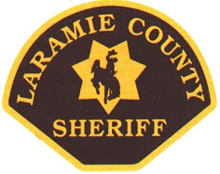
LARAMIE COUNTY SHERIFF’S DEPARTMENT Danny L. Glick
1910 PIONEER AVENUE SHERIFF
CHEYENNE, WYOMING 82001

LARAMIE COUNTY JUVENILE SERVICES CENTER
13794 PRAIRIE CENTER CIRCLE
CHEYENNE, WYOMING 82009
Wyoming’s First County - Established 1867

Sheriff Danny L. Glick
Laramie County, Wyoming

Sheriff Glick has worked his entire 38+ year career in Laramie County with the Sheriff’s Office.

Sheriff Glick began his career as a Patrol Deputy in July of 1981.

In November of 2002, the citizens of Laramie County elected Sheriff Glick for his first term of office, and most recently sworn in for his fifth term on January 7, 2019.

Sheriff Glick has served as President of the Wyoming Sheriff’s Association, President of the Wyoming Sheriff’s and Chiefs of Police Association, President of the Western States Sheriff’s Association, and President of the National Sheriff’s Association.

