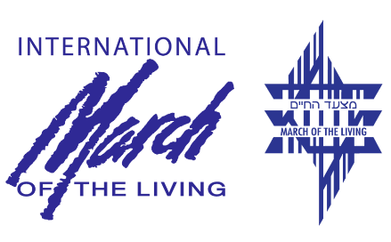
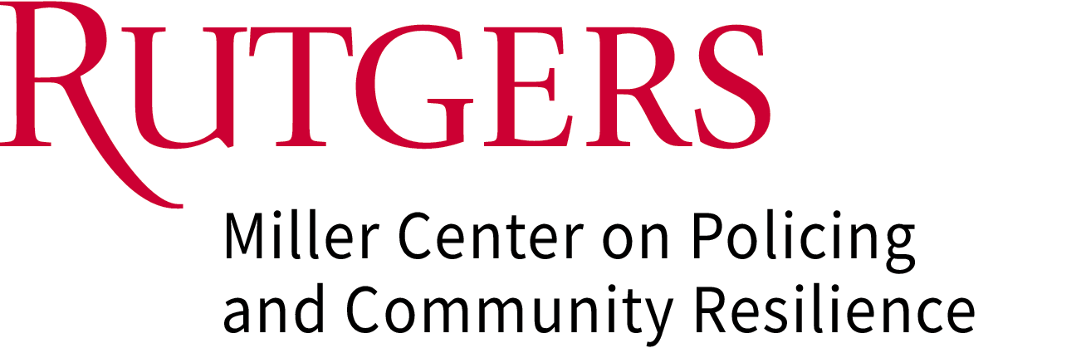

New Brunswick, N.J. (May 2024) — An intercontinental delegation of chiefs of police and senior law enforcement executives will convene in Krakow, Poland, to participate in the International March of the Living, a formal remembrance of the horrors of the Holocaust. The annual event, which began in 1988, takes place this year on 6 May 2024.
The inclusion of senior law enforcement executives is a joint effort of the International March of the Living (MOTL) and the Miller Center on Policing and Community Resilience at Rutgers University (Miller Center), with support from major law enforcement associations such as the National Sheriffs’ Association, EUROPOL, GCLETE, and academic institutions including the Eagleton Institute of Politics and University of Ottawa Professional Development Institute. The law enforcement executives will join with heads of state, government officials, students, and other members of civil society in a demonstration of their commitment to countering antisemitism and hatred and targeted violence against all vulnerable communities. The mission will be filmed with the footage utilized to further develop five modules of training materials for law enforcement officials.
Senior law enforcement executives representing Canada, the European Union, the United States, New Jersey State Police, the Washington, DC Metropolitan Police, and the International Association of Campus Law Enforcement Administrators, will march from Auschwitz to Birkenau alongside thousands of other participants. The delegation will also include New Jersey State Trooper I Mudduser Malik, founding member and President of the New Jersey Muslim Officers Society, and NJSP Sgt. First Class Marc J. Zislin, who will march in solidarity against antisemitism and hatred in all of its forms.
After this historic event, the Miller Center, in conjunction with the March of the Living, DC Metropolitan Police, Antwerp Police, University of Ottawa PDI, and Europol, along with other distinguished police officials, will work together to develop a groundbreaking educational program for law enforcement agencies in North America and Europe. This program will include special training tracks to (1) explore historical events through the eyes of law enforcement, (2) examine policing within the legal and political framework of Nazi Germany and other regions across the globe impacted by genocide, and (3) address the core values of democracy. Given the central role of New Jersey officials and institutions in this initiative, the New Jersey Senate issued a resolution commending the Miller Center’s commitment to combatting hate and intolerance.
The mission will be led by the Miller Center’s Chief Advisor for Policy and Global Policing, Paul Goldenberg, who formerly served as the first Chief of the New Jersey State Attorney General’s Office for Bias Crime and Community Relations, and as former co-Chair of the US Department of Homeland Security Advisory Council’s Subcommittees addressing Targeted Attacks Against Faith-Based Communities. Paul said, "This mission and training represent a tremendous step in bringing law enforcement closer to the communities they serve," said Paul Goldenberg. "The hate that led to the Holocaust dehumanized certain citizens to the police and the public alike. Our delegation recognizes that police have a powerful role in engendering community, mutual respect, and human decency."
Sheriff Greg Champagne from St. Charles Paris, LA and President of the National Sheriffs’ Association said, “It is my extreme honor to represent the 3082 Sheriffs of America in attending this commemorative event, which is of indescribable significance now as much as ever. In the rising rate of hate in our world, law enforcement executives must stand tall and strong against it and, in particular, Antisemitism, which is reaching concerning levels. We must demonstrate by our presence that the rule of law is the best way to give true meaning to the phrase ‘NEVER AGAIN!’”
Chief Paul M. Cell, RET, Executive Director of the International Association of Campus Law Enforcement Administrators, will be joining the March for the first time, said, “It is an honor to participate in the International March of Living ceremony. For me, the ceremony is a meaningful and solemn experience, offering an opportunity to pay respects to the victims and to reflect on the importance of remembrance and education to prevent such atrocities from happening again. It's also a way to show solidarity with the survivors and their descendants and to ensure that the stories of those who endured unimaginable suffering are never forgotten.”
Colonel Patrick J. Callahan, Superintendent of the New Jersey State Police, who will also attend the March, said, “The journey of Jewish and Muslim New Jersey State Troopers to Poland for the March of the Living exemplifies the profound importance of standing together in solidarity and embracing mutual understanding. This annual event, which commemorates the victims of the Holocaust and celebrates the resilience of the human spirit, transcends cultural and religious boundaries, offering a poignant reminder of our shared humanity.”
John J. Farmer, Jr., Director of the Miller Center, said, “The significance of law enforcement leaders from many nations and faiths participating in the March of the Living and developing training based on that experience cannot be overstated. Their commitment to stand against antisemitism and hatred in all of its forms represents law enforcement at its best.”
###
ABOUT THE MARCH OF THE LIVING IN POLAND
The March of the Living has become an annual event in Poland and a heralded international resource in education about the Holocaust, wholly driven with the purpose and goal of ensuring that such a campaign of hatred will never happen again. The March of the Living doesn’t view the Holocaust solely in its historical context. Instead, it is a source from which much can be learned in our endless efforts to improve society. We also recognize that no level of classroom or traditional education can rival the experience of on the ground visits to the sites where these atrocities took place.
ABOUT THE INTERNATIONAL MARCH OF THE LIVING
Then International March of the Living is an annual educational program, bringing individuals from around the world to Poland and Israel to study the history of the Holocaust and to examine the roots of prejudice, intolerance and hatred. Since its inception in 1988, more than 300,000 alumni from 50 countries have marched down the same 3-kilometer path leading from Auschwitz to Birkenau on Holocaust Remembrance Day – Yom Hashoah –as a tribute to all victims of the Holocaust.
ABOUT THE MILLER CENTER ON POLICING AND COMMUNITY RESILIENCE
The Miller Center on Policing and Community Resilience engages in education and public service focused on protecting vulnerable communities. The Eagleton affiliated center identifies and disseminates best practices, offers training workshops, consults on security and civil liberties, and undertakes research. The Miller Center, a product of the combined efforts of the former Centers on Policing and Community Protection and Resilience, is composed of individuals with a broad range of experience in the public safety arena. Its mission is to integrate research and evidence-based best practices into police operations, violence reduction, problem-solving, community policing, education, training, and the development of criminal justice policy and practice. The Center’s efforts and findings directly help public safety professionals and agencies, and community organizations more effectively protect and serve their communities.

ABOUT THE EAGLETON INSTITUTE OF POLITICS
The Eagleton Institute of Politics at Rutgers University—New Brunswick explores state and national politics through research, education, and public service, linking the study of politics with its day—to—day practice. The Institute focuses attention on how the American political system works, how it changes, and how it might work better. To learn more about Eagleton programs and expertise, visit eagleton.rutgers.edu.
ABOUT THE GLOBAL CONSORTIUM OF LAW ENFORCEMENT TRAINING EXECUTIVES (GCLETE)
GCLETE is a 501(c)3 organization established exclusively to provide police academy training directors, commandants, and superintendents with exceptional value through the exchange of innovative curriculum and methods or programs that enhance the educational, training, and certification processes of the law enforcement professional. GCLETE provides a coordination hub for the centralization of best practices, information sharing, and services provided to member agencies and academic institutions and serves as the coordinating body for chief executive officers of training academies and institutions to allow the transfer of industry-recognized best practices from one agency to another.
ABOUT RUTGERS—NEW BRUNSWICK
Rutgers University–New Brunswick is where Rutgers, the State University of New Jersey, began more than 250 years ago. Ranked among the world’s top 60 universities, Rutgers’s flagship is a leading public research institution and a member of the prestigious Association of American Universities. It has an internationally acclaimed faculty, 12 degree—granting schools and the Big Ten Conference’s most diverse student body.

