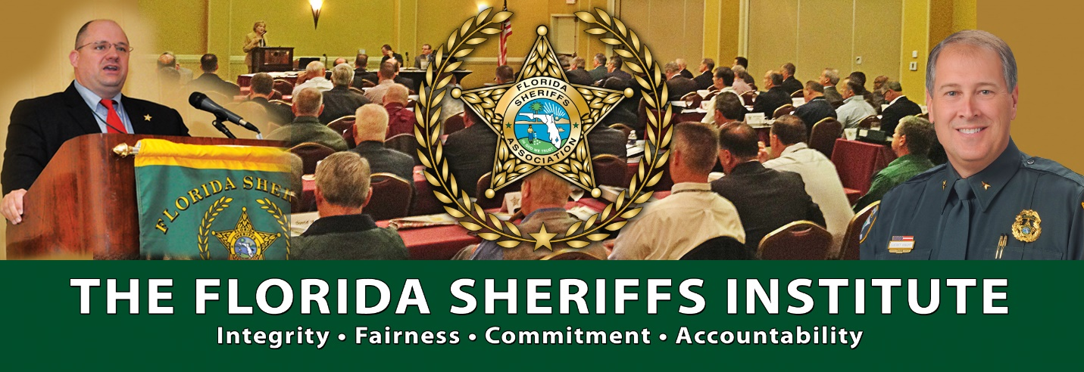

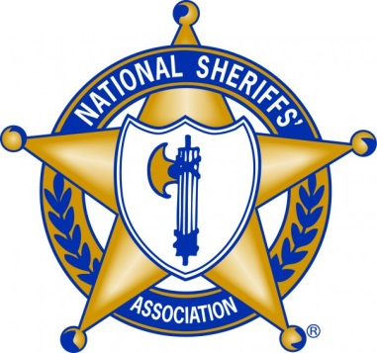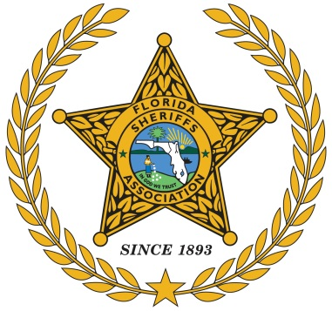

The Florida Sheriffs Institute has partnered with the National Sheriffs’ Association to present the National Sheriffs’ Association
Court Security Course

This two-day course is fully funded by proceeds from the FSA Specialty License Tag sales.

Dates: March 7th and 8th (two-day course)

Location: The Brevard County Sheriff’s Office North Precinct station located at: 2290 Columbia Blvd. Titusville, FL 32780

Content: Will include:
- Vulnerability Assessments
- Courtroom Security
- Defendant Management
- Judicial Threat Management
- Emergency Events
- High-Profile Cases

Who should attend: Both experienced and entry level court security officers/bailiffs.

Instructors: Mr. Tom Lorito, Executive Assistant to the Administrative Judge (ret) Suffolk County Courts, New York.
Mr. Jim Ludolph, Court Security Administrator (ret) Peoria County Sheriff’s Office, Illinois.

Class size: The class will be limited to 30 seats.

Tuition: This class is being provided tuition-free and is funded by the sale of the FSA Specialty License Tags.

Class facilitator: David Brand, Florida Sheriffs Association 850-877-2165 dbrand@flsheriffs.org

Registration: Email the attached registration form to Ms. Patti Brigance, Florida Sheriffs Association, at: pbrigance@flsheriffs.org

