Southwestern Consolidated School District’s Emergency Response System

Safest School in America protected by an Emergency Response System per Indiana’s School Safety Law Guidelines--- Public Law 27---Effective July 01,2017
Indiana Sheriffs Best Practice Solution for School Safety
Endorsed by: The Indiana Chiefs of Police Association, the Indiana SWAT Association, The Indiana State Teachers Association, Principals and Superintendents Associations
Aired September 2015 On the NBC Today Show Rossen Report
https://youtu.be/a2ewuHvoIDA

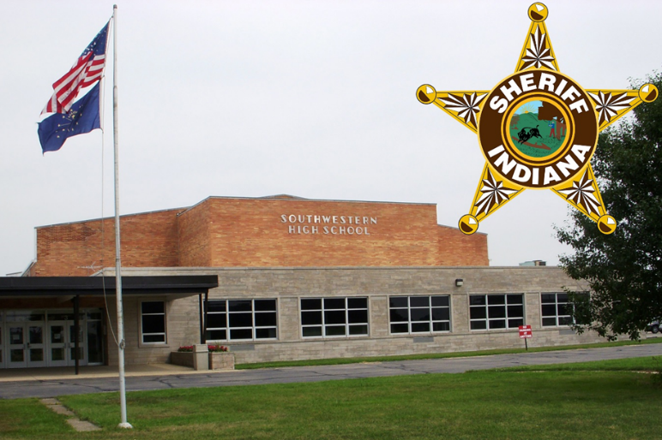

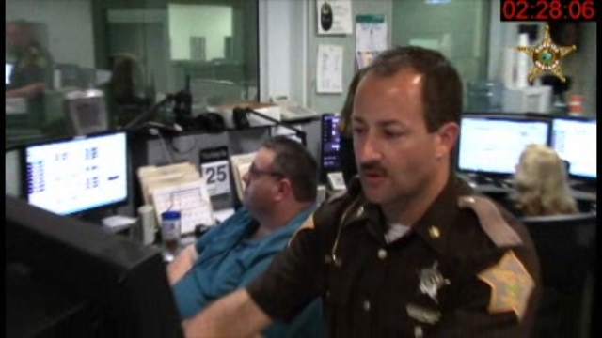

- Direct Internet protocol (IP) Virtual Private Network (VPN) connectivity from the high school to the Shelby County Sheriff’s E 9-1-1 Call Center for the following:
  - Immediate notification a life threat incident has begun.
  - A continuous flow of real-time actionable intelligence---location of the attacker, subject description, identification of the weapons platform, and continual tracking of the attacker.
  - The ability to launch countermeasures to delay or stop an attack while responders are in-route.
  - The ability to communicate facility and classroom status that can also communicate the condition of individuals.
  - Life threatening wounds are communicated from the classrooms to be prioritized for on-site triage, evacuation and notification to hospital emergency room.
- Immediate text notification of the life threat incident to key school safety stakeholders
- Every classroom, office, library, and cafeteria is a protected space.
  - Classroom/office doors are designed to with stand breaching attempts by an attacker. Classroom doors lock when closed. Common space doors like the one for the Admin office lock electronically on alert.
  - Ballistic glass will protect entry doors and exterior windows. In progress.
  - Protected squares made from AR500 steel will provide cover for the elementary children in classrooms with soft walls—in progress. The elementary school is currently being equipped with an Emergency Response System.
- During the school day there is Active alarm monitoring for forced penetration of entry doors, exterior windows. There is controlled access into the school.
- During the school day there is an Active Alert System. All teachers and staff wear a wireless alert fob that can be activated in a couple seconds---by pushing up on the guard and pressing the button. This puts the school in an Active Attacker alert status in one second. The strobes and horns alert all classrooms, hallways, and offices. Simultaneously, the fob press alerts all Emergency Response Stations. These stations provide in aural alert including the two at the Sheriffs E 9-1-1 Center. Further, the alarm control panel sends a text message to all Emergency Management stake holders that a life threat incident has begun. All of this happens in less than 5 seconds.
- During the school day there are strict security protocols in place to prevent an incident and to quickly respond to an incident.
  - There is access control, and no one is allowed in the school during a change of classes.
  - Teachers are at their doors during a change of class. Everyone is alert and watching.
  - If something is seen or heard, a teacher will press their fob putting the school in alarm---the students are taught to seek shelter in the nearest classroom and not to queue up---move to the next nearest classroom.
  - Students do not automatically evacuate on a fire alarm. An administrator checks the hallways via video for any person standing in the hallway. If there is a person in the hallway, the Active Shooter alert is sounded overriding the fire alarm alert. If the hallways are clear, a PA announcement is made to evacuate.

- The VPN and the Emergency Response Station with a Graphic User Interface. The VPN connection is controlled by a highly secure Router that translates static IP addresses to internal addresses. The alarm data and data communications take place in 1-2 seconds. The connectivity at the E 9-1-1 Center is with two Emergency Response Workstations that are configure into this Virtual Private Network. The alert and all the actionable intelligence is all shown on a simple to use graphic interface. The graphic User Interface serves as a platform to fire countermeasures.

Hallway Slice of the Graphic User Interface--High density of sensors and detectors for Actionable Intelligence integrated with live video. The blue circle icon with a white star burst is a motion detector in alarm. Two of the three camera icons are pointed at the motion and when activated with a mouse click will show live video in real-time verifying who has activated the motion in alarm. The next green circle is a motion that is armed but not in alarm. The transmission of alarm data is 1-2 seconds

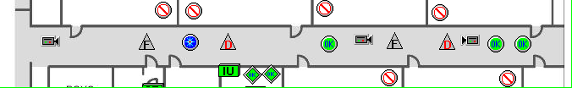

Graphic User Interface—A Platform for Firing Countermeasures----the F and D Triangles show the location of a Hot Zone location--- Each Hot Zone consist of three (3) Fire Suppression Generators

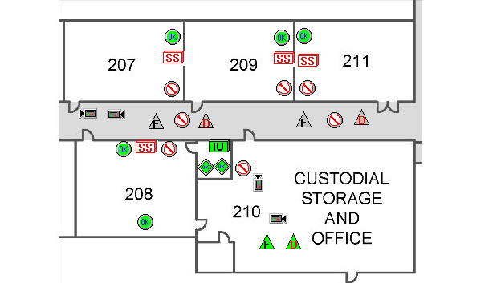
Firing Sequence
Counter Measures Monitoring Screen
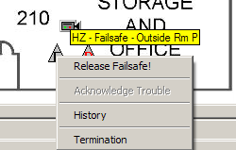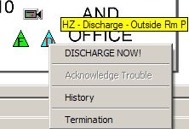

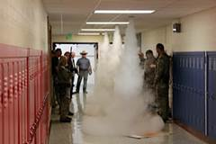
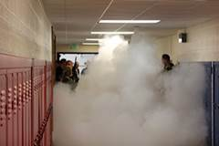
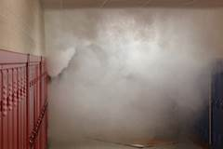
Counter Measures Released

